**WRITE UP**

**PROJECT: Make an E-commerce Website for Sporty Shoes**

**Project Description:**

1. Creating a web application that

1. Manage the products in the store including categorizing them. Categories include adding new category in the list.
2. Browse the list of users who have signed up and be able to search users. Viewing the list of users.
3. Adding the new product details of the Category.
4. See purchase reports filtered by date and Category.

**Sprint Planning:**

The project is planned to be completed in 2 sprints.

Tasks assumed to be completed in the sprint are:

· Creating the flow of the application

· Initializing git repository to track changes as development progresses.

· Writing the Dynamic web project program to fulfill the requirements of the project.

· Testing the Dynamic web project program with different kinds of User input

· Pushing code to GitHub

· Creating this specification document highlighting application capabilities, appearance, and user interactions.

**Application Flow:**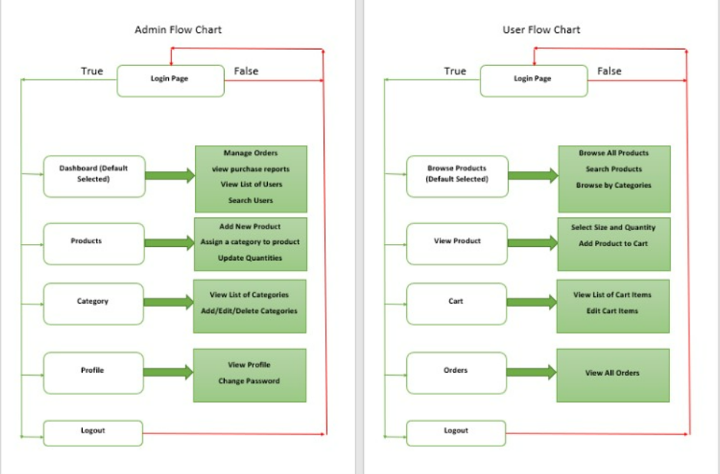

**Core concepts used in project:**

1. Build the Maven web Project.

2. Spring boot, MySQL, hibernate concepts

**Conclusion:**

This project is designed for creating an e-commerce website for sporty shoes.